**Worksheet-2.1**

**Student Name**: Sahil Kaundal **UID:** 21BCS8197

**Branch**: CSE(LEET) **Section/Group:** 807/B

**Semester**: 4th **Date of Performance**: 22/03/2022

**Subject Name**: CN Lab **Subject Code:** 20CSP-257

1. **Aim/Overview of the practical:**

Create a network that shows the working of hub and also write the steps how to implement it.

1. **Task to be done/ Which logistics used:**

Create a network that shows the working of hub and also write the steps how to implement it in Cisco packet tracer.

1. **Steps for experiment/practical/Code:**

Step 1- Attach required devices (Hub/Switch/Router) in the packet tracer software.

Step 2- Assign IP address to devices.

Step 3-Select source and destination and drop packet from source to destination.

Step 4- Go to Simulation mode and click capture/Play.

Step 5- Simulation will start and packet will only be accepted by destination.

1. **Result/Output/Writing Summary:**

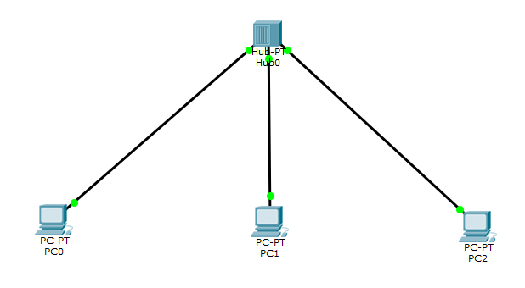

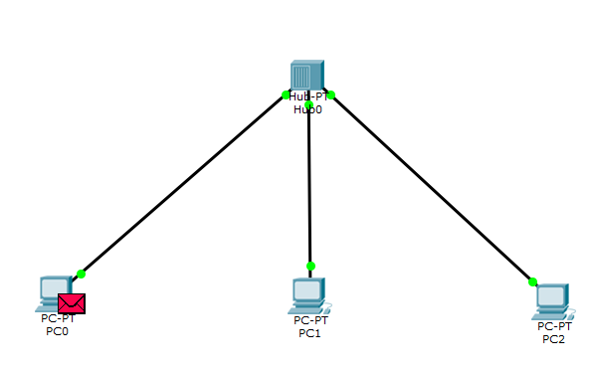

**Simulation:-**

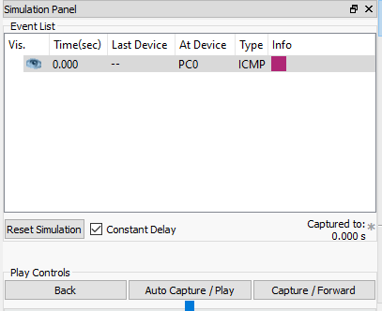

**Outcome:-**

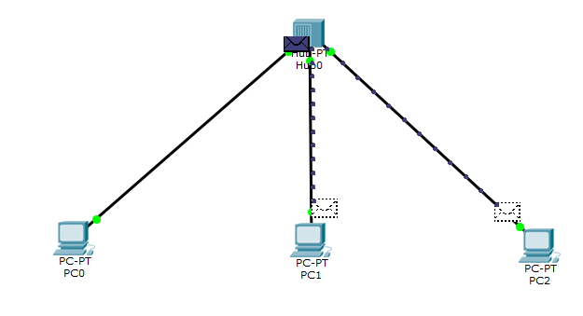

**Result:-**

I have successfully completed this experiment.

**Learning outcomes (What I have learnt):**

1. Working of Hub.
2. Created a network that shows the working of hub in cisco packet tracer.

**Evaluation Grid (To be created as per the SOP and Assessment guidelines by the faculty):**

|  |  |  |  |
| --- | --- | --- | --- |
| Sr. No. | Parameters | Marks Obtained | Maximum Marks |
| 1. |  |  |  |
| 2. |  |  |  |
| 3. |  |  |  |
|  |  |  |  |